Math Circle Problem Set 4. Name:

Problem 4.1: I went to each planet in the solar system, but I forgot exactly which order I visited them. Here is what I remember:
- I went to all the gas/ice giants before I went to any other plants.
- I visited Mars sometime before I visited Venus.
- After Saturn I went to Mercury next.
- After Neptune I went to Uranus next.
- I forgot what my next stop was after Jupiter, but I remember it wasn’t Saturn.
- My last stop was at Earth so I could go home!
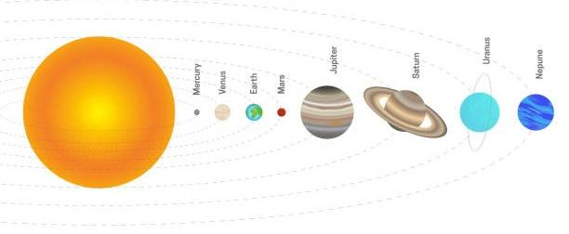
Problem 4.2: Tile the following shape with one each of the green, purple, yellow, blue, and red pieces. (The paper might not be exactly the right size - the small green triangle is supposed to be the same size as the triangles on the paper.)
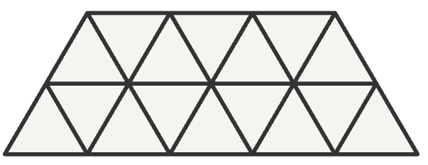

Problem 4.3: If I want to fill up this shape entirely by using the red trapezoid tile, how many trapezoids will I need? How many triangles will be left uncovered? NOTE: we’re not allowed to have any trapezoids go over the edge.

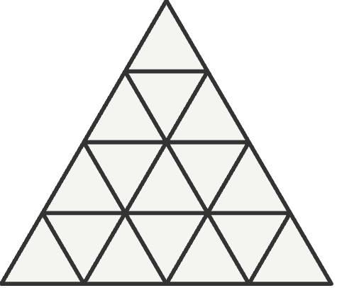

Problem 4.4: Is it possible for any of the triangles to be the one left over? Which ones don’t work?

Problem 4.5: Because of symmetry, we don’t need to check every triangle. For example, the corners are all the same “type” of triangle. How many “types” of triangle are there total? Label them with the letters A, B, C, etc.

Fun fact: mathematicians call these “types” of things equivalence classes. So another way to ask this question is: How many equivalence classes of triangles are there?
Problem 4.6: Mary is walking from her house to her school. Her house (the red square) is three blocks south and three blocks west of her school (the red star). She has to walk six blocks total, but there are lots of options for how she could walk. For instance, she could go three blocks east and then three blocks north (EEENNN). Or she could go two blocks east, three blocks north, one block east (EENNNE).

How many ways can you find for Mary to walk to school? If you run out of space below, you can draw more grids on the back.
